**UML AND TESTING TOOLS LAB**

**E - WASTE**

**MANAGEMENT SYSTEM**

**(BATCH-13)**

**BACHELOR OF TECHNOLOGY**

**IN**

**INFORMATION TECHNOLOGY**

**Submitted By:**

1. Mr. P. Sai Mahesh (A21126511118)

2. Miss. S. Niveditha (A21126511121)

3. Miss. D. Satwika (A21126511084)

4. Mr. CH. Guna Venkat Chowdary (A21126511078)

**Faculty**

**Mrs. A. Surekha**

**Assistant Professor**



**DEPARTMENT OF INFROMATION TECHNOLOGY**

**ANIL NEERUKONDA INSTITUTE OF TECHNOLOGY AND SCIENCES**

**(UGC AUTONOMOUS)**

**ACKNOWLEDGMENT**

An endeavour over a long period can be successful with the advice and support of many well-wishers. We take this opportunity to express our gratitude and appreciation to all of them. We awe our tributes to Dr. M. Rekha Sundari, Head of the Department, Information technology, ANITS, for providing us with the required facilities for the implementation of the project work.

We wish to express our sincere thanks and gratitude for lecturer in charge Mrs. A. Surekha Mam, Assistant Professor, of Information Technology, ANITS for analysing problems associated with our project work and for guiding us throughout the project. We express our warm and sincere thanks for the encouragement, untiring guidance and the confidence she had shown in us. We are immensely indebted for her valuable guidance throughout our project. We thank all the staff members of IT Department for their valuable devices and for providing resources and when required.

**DEPARTMENT OF INFORMATION TECHNOLOGY**

**ANIL NEERUKONDA INSTITUTE OF TECHNOLOGY AND SCIENCES**

###### (UGC AUTONOMOUS)

(Affiliated to AU, Approved by AICTE and Accredited by NBA & NAAC with ‘A’Grade, Sangivalasa, Bheemili mandal, Visakhapatnam dist.(A.P)



**CERTIFICATE**

This is to certify that the project reported entitled **“E - WASTE MANAGEMENT SYSTEM”** submitted by P. SAI MAHESH, S. NIVEDITHA, D. SADWIKA, CH. GUNA VENKAT CHOWDARY in partial fulfilment of the requirements for the award of the degree of **Bachelor of Technology** in **Information Technology** in Anil Neerukonda Institute of technology and sciences, Visakhapatnam is a record of work carried out under my guidance and supervision.

**Lecturer In Charge** **Head of the Department**

Mrs. A. Surekha, Prof M. Rekha Sundari,

Department of IT Department of IT

**Table of Contents**

**1. Introduction 00- 07**

**1.1 Problem Statement 06**

**1.2 Description 06**

**1.3 Requirements of Actors 07**

**2. Software Requirement Specifications 08 - 09**

**2.1 Introduction 08**

**2.2 System Overview 09**

**3. Functional Requirements 10**

**3.1 Admin Functionalities 10**

**3.2 Customer Functionalities 3.3 Collection agent Functionalities**

**4. Non – Functional Requirements 11**

**4.1 Security 11**

**4.2 Performance 11**

**4.3 Usability 11**

**4.4 Reliability 11**

**4.5 Scalability 11**

**5. UML Diagrams 12- 19**

**5.1 Use Case Diagram 13**

**5.2 Class Diagram 14**

**5.3 State Chart Diagram 15**

**5.4 Activity Diagram 16**

**5.5 Sequence Diagram 17**

**5.6 Collaboration Diagram 18**

**5.7 Component Diagram 19**

**5.8 Deployment Diagram 20**

**6. Website 21- 35**

**6.1 Sample Code 21**

**6.2 Home Page 22**

**6.3 Login Page 23**

**6.4 Signup Page 23**

**6.5 Main Page 24**

**6.6 Sell Item Page 24**

**6.7 Item selection Page 25**

**6.8 Buy Item Page 25**

**6.9 Payment Page 26**

**6.10 Payment Acknowledgement Page 26**

**6.11 About us Page 27**

**6.12 Contact Page 27**

**6.13 Feedback Page 27**

**6.14 After Logout 36**

**7. Conclusion 37**

**INTRODUCTION:**

**1.1 Problem Statement**:

* The escalating production and improper disposal of electronic waste (e-waste) pose a severe environmental and health hazard. Current e-waste management practices are fragmented, inefficient, and often result in electronic devices being discarded inappropriately.
* This contributes to the contamination of landfills and the release of hazardous materials into the environment.

**1.2 Description:**

* This project is a high-quality software to manage all the data of buyers, sellers.
* The software is designed to handle the daily transactions of the e-waste and search the details
* It also helps to register the details of sellers, e-waste collection details. ACTORS in this project.
* The software application is engineered to be adaptable to meet all the evolving demands of e-waste management in the future.
* This project will overcome the problems that occur in the existing system.

**1.3 REQUIREMENTS OF ACTORS:**

**Seller:**

* Register
* List E-Waste Items
* Manage Listings
* Selling Price
* Contact Details

**Buyer:**

* Register
* Browse E-Waste Items
* Buyer’s Address
* Payment Details
* Item Status

**Availability**

* Currently available electronic gadgets

**Records**

* Transactions
* Seller records (stores Seller’s id and the Seller’s data)
* Buyer records (stores the Buyer’s data)

SOFTWARE REQUIREMENT SPECIFICATIONS:

**2.1 Introduction**

**Purpose:**

* The E-Waste Management System, herein referred to as "EWMS," is comprehensive software solution designed to address the growing global concern of electronic waste (e-waste) ismanagement. E-waste, which encompasses discarded electronic and electrical equipment, presents a significant environmental and health challenge due to improper disposal and recycling practices. The primary purpose of the EWMS is to provide an integrated platform that facilitates responsible e-waste collection, tracking, recycling, and disposal. This document serves as the Software Requirements Specification for the EWMS, outlining the functional and non-functional requirements necessary to develop and deploy the system effectively.

**Scope:**

* The scope of the EWMS encompasses the entire lifecycle of electronic waste management, from the point of e-waste generation to its final environmentally responsible disposal or recycling. The system addresses the needs of various stakeholders, including consumers, e-waste collection agencies, recycling centres, regulatory bodies, and environmental organizations. It offers functionalities for scheduling e-waste pickups, tracking the movement of e-waste shipments, ensuring secure data destruction, and generating comprehensive reports on the environmental impact of e-waste recycling and disposal practices.

**Technologies used:**

* Front-End Development:

1.Html (Hyper Text Mark-up Language)

* CSS (Cascading Style Sheets)

2. Back-End Development:

* PHP
* MySQL
* JS

**2.2 System Overview**

**System Description:**

* This project is built to maintaining all the information pertaining to blood donor, patient information and the stock of all the blood group available in the bank.
* Aim is to provide transparency in this field, make the process of obtaining blood from a blood bank hassle free and corruption free and make the system of blood bank management effective.

**Users:**

* **Admin:** Admin is the main role in the system, admin can manage all the activities like managing donor, patients and blood stock etc.
* **Donor:** Donor is also an important role in the system. If any person or donor wants to donate the blood, he or she has to register themselves first. Once he or she registers he/she can login to the system where he can manage or execute donor’s activities.
* **Patients:** Patient is the one who is suffering from any disease and he needs blood. He can go to the system and register himself as a patient. Once he registers, he/she can login to the system and access patient dashboard.

FUNCTIONAL REQUIREMENTS

**3.1 Admin Functionalities:**

* Check the availability of electrical gadgets
* Manage customers
* Manage collection agent
* Logout

**3.2 Customer Functionalities:**

* Make payments
* Check the status of electrical gadgets
* Logout

**3.3 Collection Agent Functionalities:**

* Manages products recycling
* Check the status of customer request
* Logout

NON – FUNCTIONAL REQUIREMENTS

**4.1 Security:**

* The system must implement robust security measures to protect sensitive data.
* User data should be stored securely, and password hashing should be employed.
* Access control should be implemented to ensure data privacy and integrity.

**4.2 Performance:**

* The system should be responsive and capable of handling a reasonable load.
* Database queries should be optimized for efficient retrieval of data.

**4.3 Usability:**

* The user interface should be user-friendly, intuitive, and accessible.
* The system should support multiple browsers and devices.

**4.4 Reliability:**

* The system should have backup and recovery mechanisms to prevent data loss.

**4.5 Scalability:**

* The system should be scalable to accommodate a growing user base and increasing data.

UML DIAGRAMS :

* UML, short for Unified Modelling Language, is a standardized modelling language consisting of an integrated set of diagrams, developed to help system and software developers for specifying, visualizing, constructing, and documenting the artifacts of software systems, as well as for business modelling and other non-software systems.
* The UML represents a collection of best engineering practices that have proven successful in the modelling of large and complex systems.
* The UML is a very important part of developing object-oriented software and the software development process.
* The UML uses mostly graphical notations to express the design of software projects.

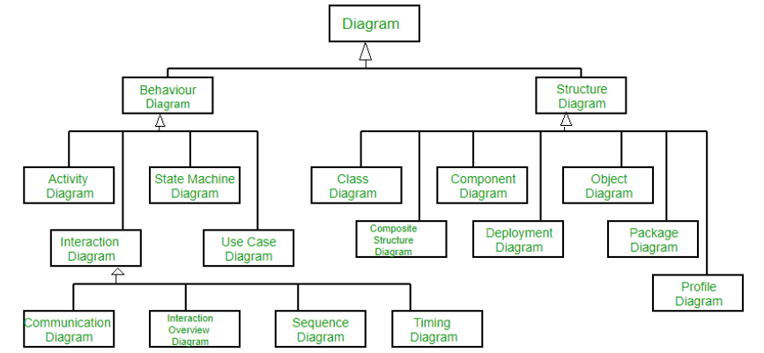

**5.1 Use case diagram:**

* Use Case Diagrams are used to depict the functionality of a system or a part of a system.
* They are widely used to illustrate the functional requirements of the system and its interaction with external agents (actors).
* A use case is basically a diagram representing different scenarios where the system can be used. A use case diagram gives us a high-level view of what the system or a part of the system does without going into implementation details.

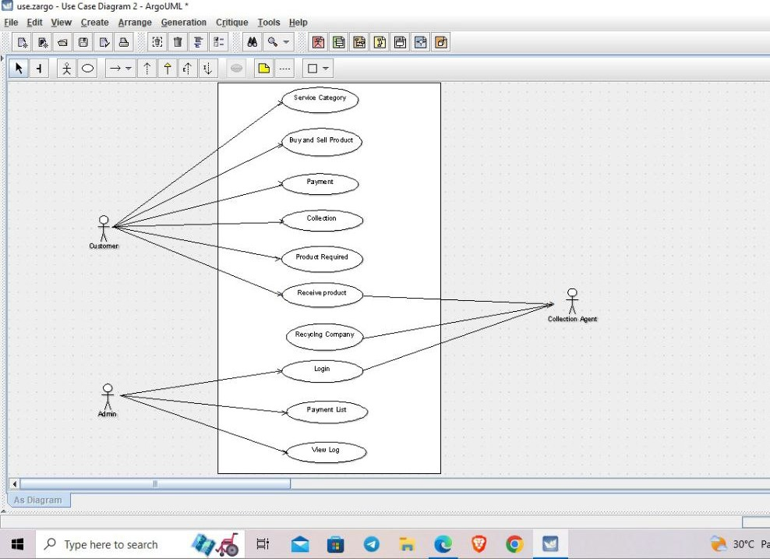

**Use Cases:**

* Service category, Buy and sell product, Payment, Collection, Product required, Receive product, Recycling company, Login, Payment List, View Log.
* **Actors:**

Customer, Admin and Collection Agent.

**5.2 Class diagram:**

* The most widely use UML diagram is the class diagram. It is the building block of all object-oriented software systems.
* We use class diagrams to depict the static structure of a system by showing system’s classes, their methods and attributes. Class diagrams also help us identify relationship between different classes or objects.

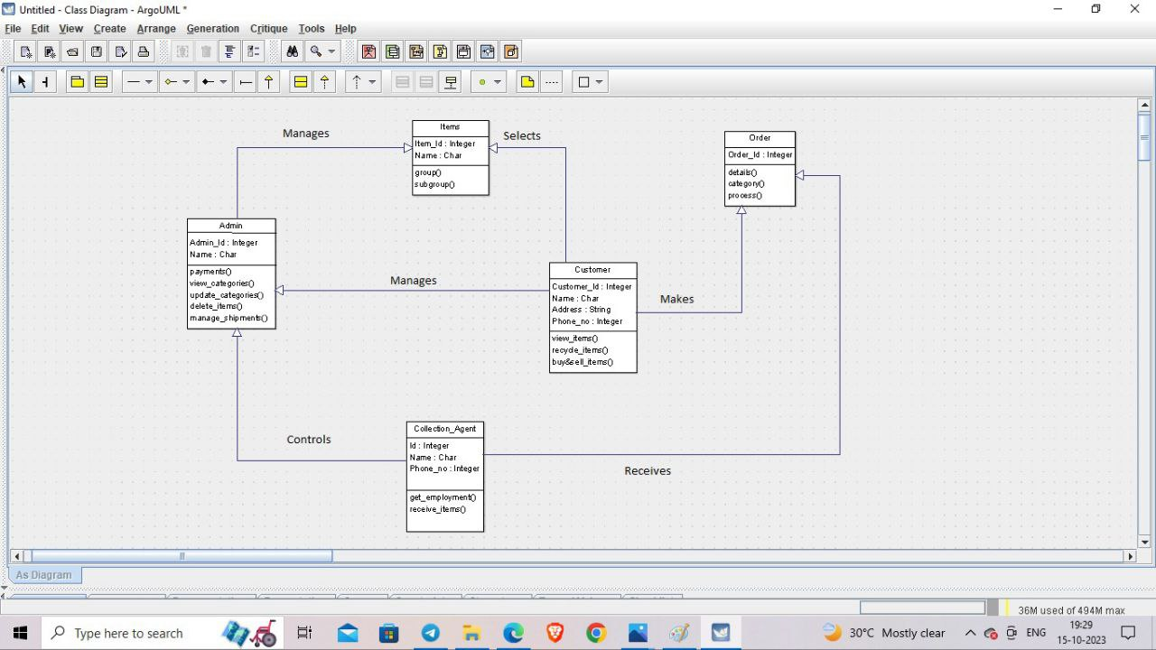

**Classes:**

* Admin, Items, Collection Agent, Customer, Order.

**5.3 State diagram:**

* A state diagram is used to represent the condition of the system or part of the system at finite instances of time. It’s a behavioural diagram and it represents the behaviour using finite state transitions.
* State diagrams are also referred to as State machines and State-chart Diagrams.
* These terms are often used interchangeably. So simply, a state diagram is used to model the dynamic behaviour of a class in response to time and changing external stimuli.

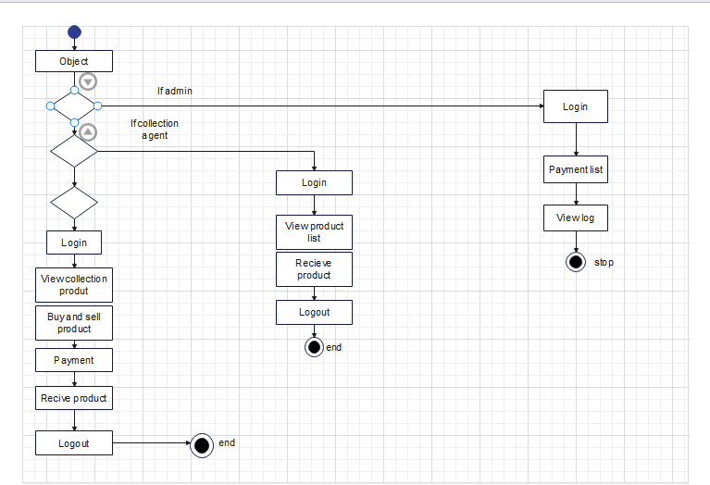

**Login Components:**

* As shown in the above State diagram we have created for admin, collection agent and customer to login into the system and access the internal functionality as shown in the above State diagram.

**5.4 Activity diagram:**

* We use Activity Diagrams to illustrate the flow of control in a system. We can also use an activity diagram to refer to the steps involved in the execution of a use case.
* We model sequential and concurrent activities using activity diagrams. So, we basically depict workflows visually using an activity diagram. An activity diagram focuses on condition of flow and the sequence in which it happens.
* We describe or depict what causes a particular event using an activity diagram.

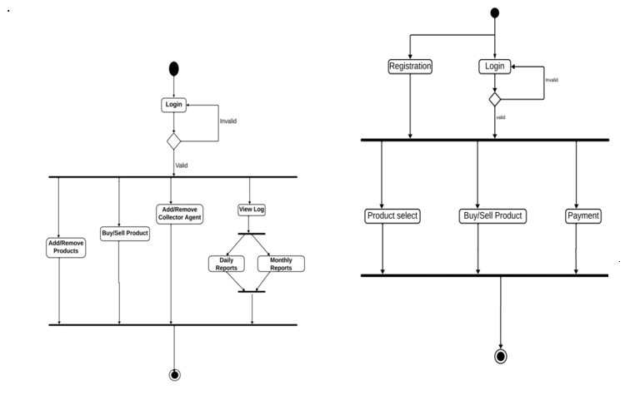

**Activities:**

* Admin will login into the system and he will manage the collection agent, manage the customer and then he will get logout from the system.
* And the customer will login in to the system and he can sell or buys e-waste products from website and then get logout from the system.
* And the collection agent will login into the system and then h and get logout from the system.

**5.5 Sequence diagram:**

* The sequence diagram represents the flow of messages in the system and is also termed as an event diagram. It helps in envisioning several dynamic scenarios.
* It portrays the communication between any two lifelines as a time-ordered sequence of events, such that these lifelines took part at the run time.

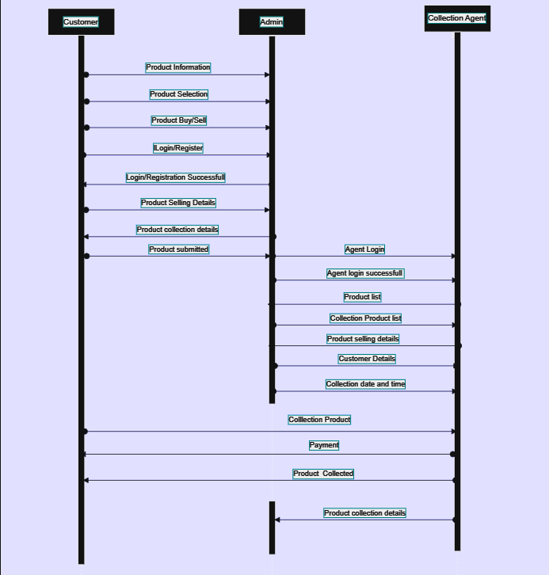

**Actors:**

* Actor
* Customer
* Collection agent

**Messages:**

* Registration
* Login
* Confirmation
* Check Status
* Vier Request

**5.6 Collaboration diagrams:**

* The collaboration diagram is used to show the relationship between the objects in a system. Both the sequence and the collaboration diagrams represent the same information but differently.
* Instead of showing the flow of messages, it depicts the architecture of the object residing in the system as it is based on object-oriented programming.
* An object consists of several features. Multiple objects present in the system are connected to each other. The collaboration diagram, which is also known as a communication diagram, is used to portray the object's architecture in the system.

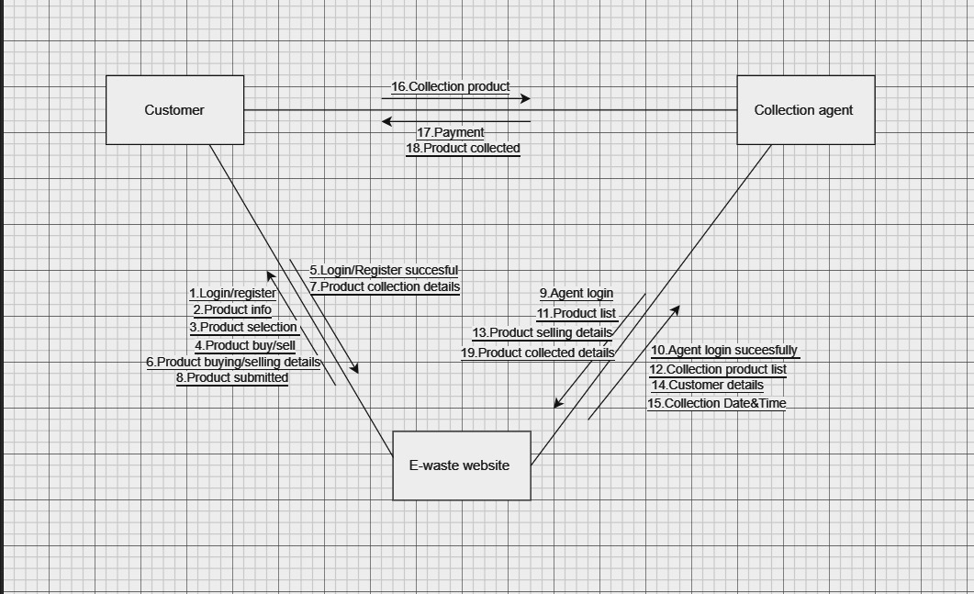

**Objects:**

* E-Waste Management System

**Actors:**

* Admin
* Customer
* Collection Agent

**5.7 Component diagram:**

* A component diagram is used to break down a large object-oriented system into the smaller components, so as to make them more manageable.
* It models the physical view of a system such as executable, files, libraries, etc. that resides within the node.
* It visualizes the relationships as well as the organization between the components present in the system. It helps in forming an executable system. A component is a single unit of the system, which is replaceable and executable.
* The implementation details of a component are hidden, and it necessitates an interface to execute a function. It is like a black box whose behaviour is explained by the provided and required interfaces.

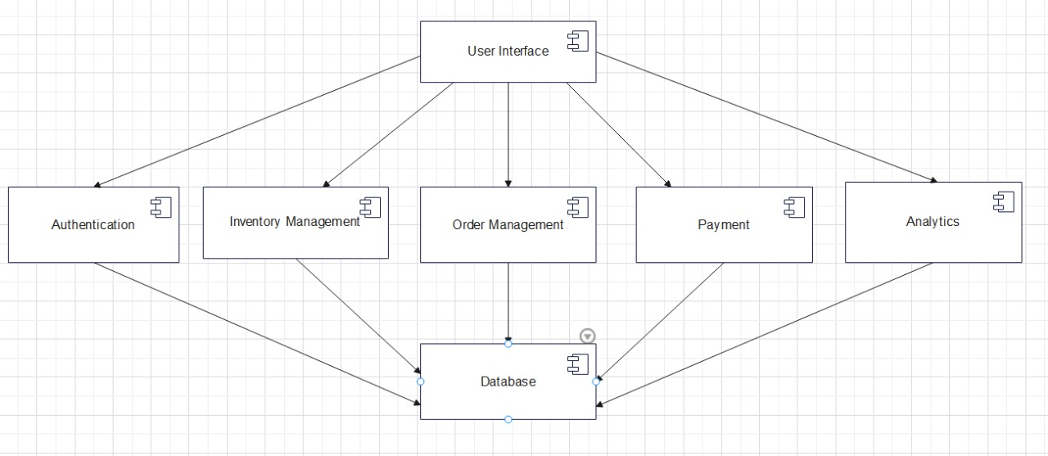

**5.8 Deployment diagram:**

* Deployment Diagrams are used to represent system hardware and its software. It tells us what hardware components exist and what software components run on them.
* We illustrate system architecture as distribution of software artifacts over distributed targets. An artifact is the information that is generated by system software.
* They are primarily used when software is being used, distributed or deployed over multiple machines with different configurations.

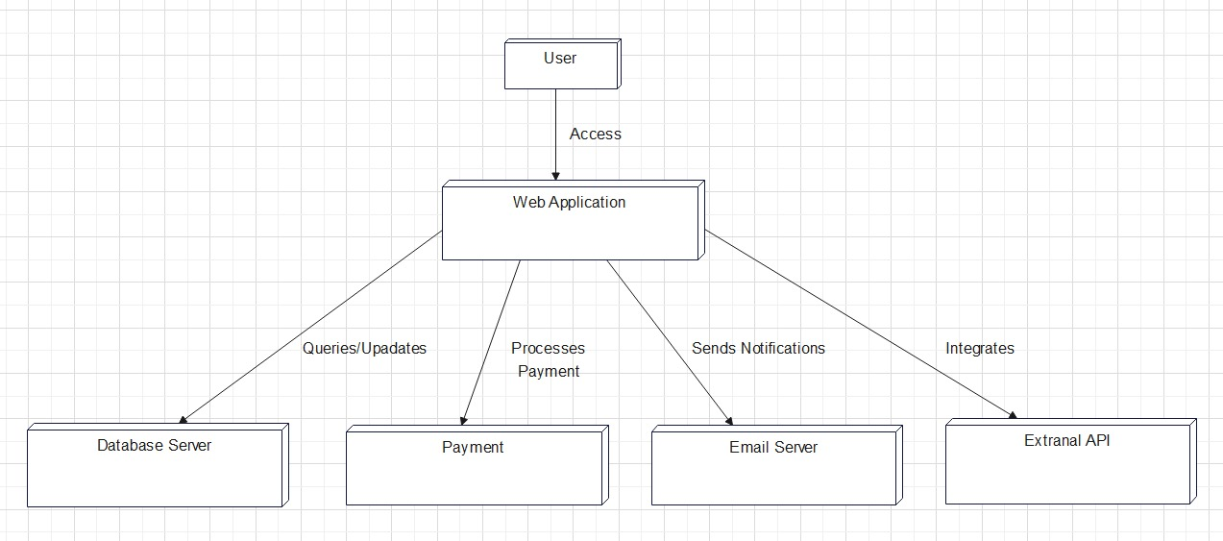

**Nodes:**

* User
* Web Application
* Database server
* Payment
* Email Server
* External API

# WEBSITE

6.1 Sample code:

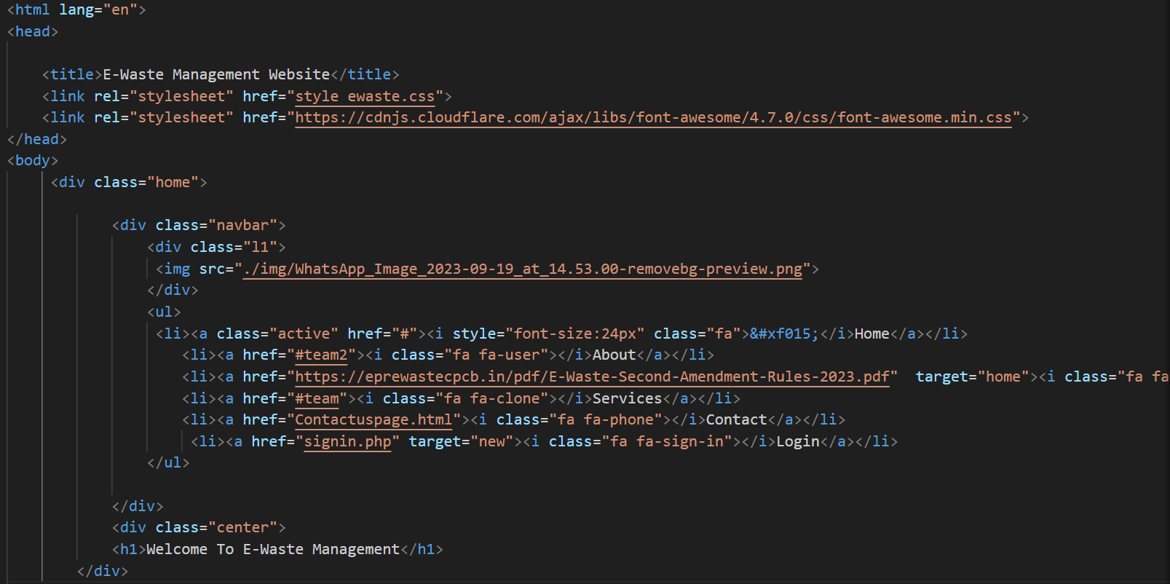

**The above is the sample code of “HOME” page.**

**6.2 Home Page:**

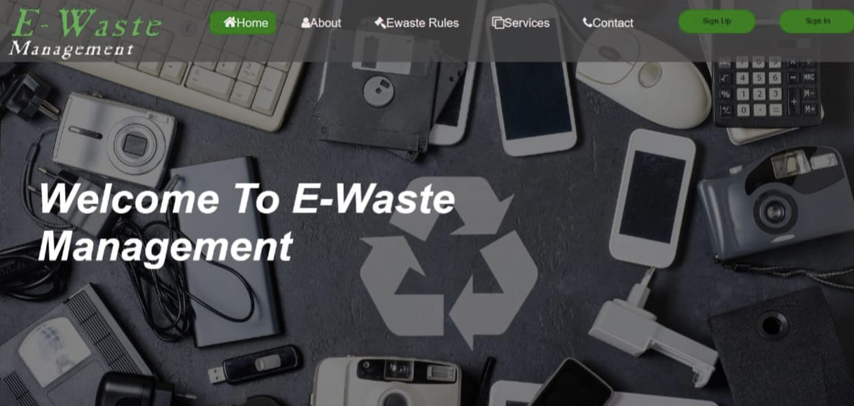

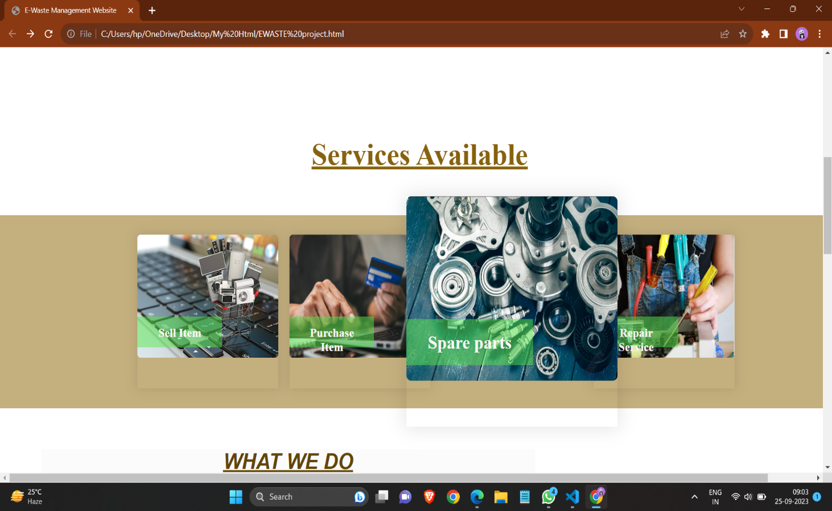

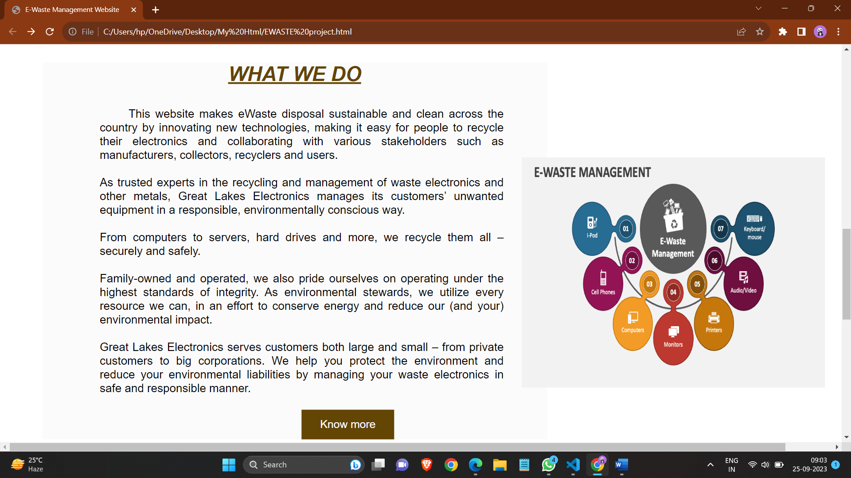

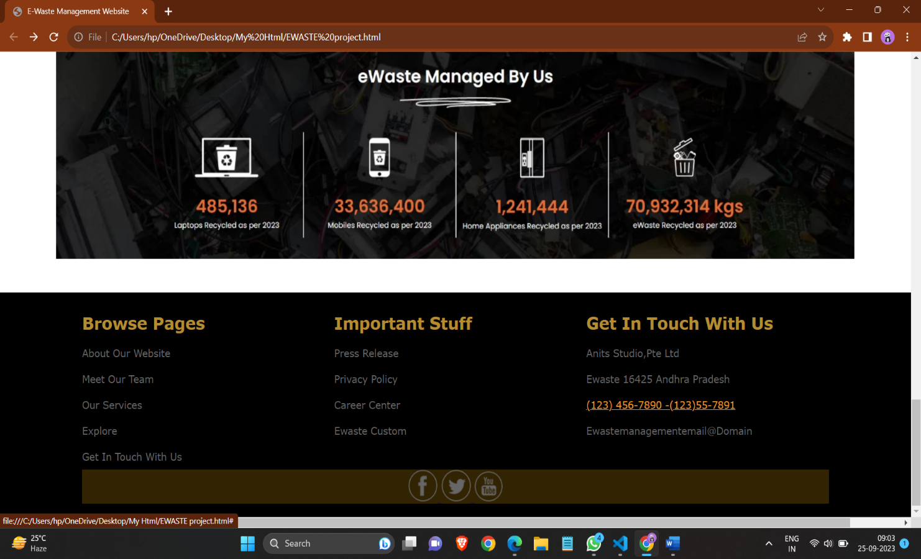

**6.3 Login page:**

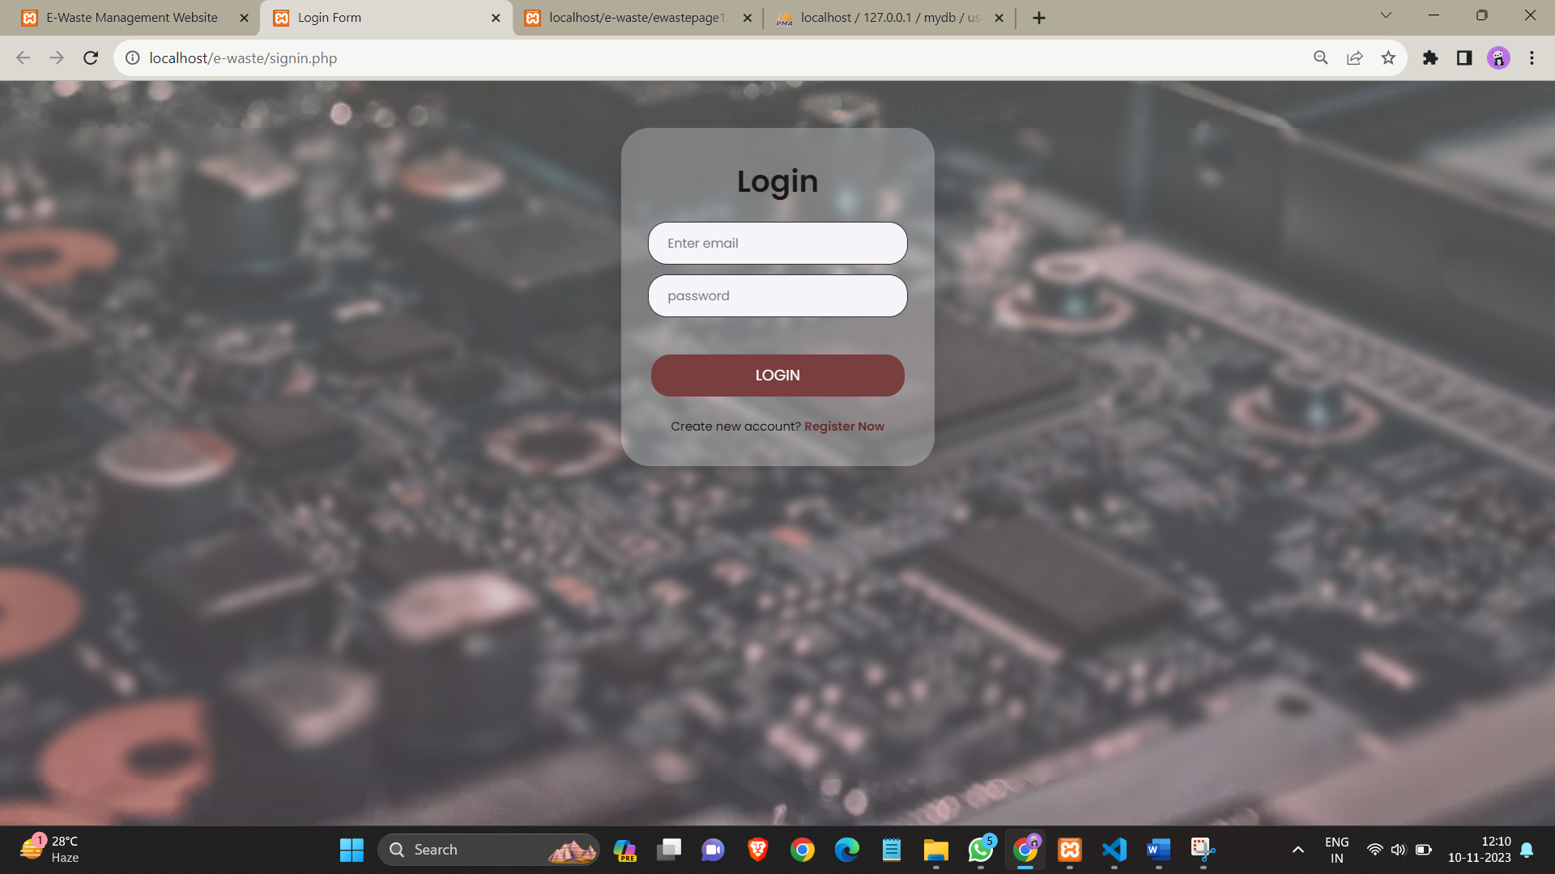

**6.4 Sign up page**:

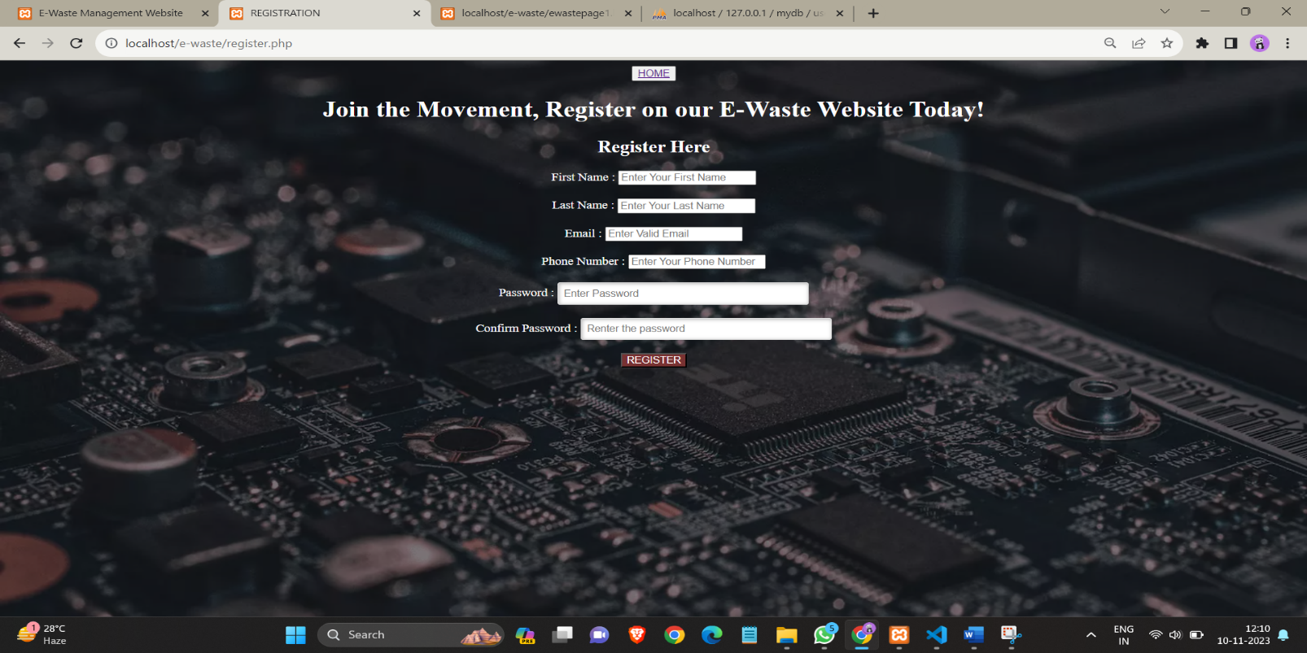

**6.5 Main page:**

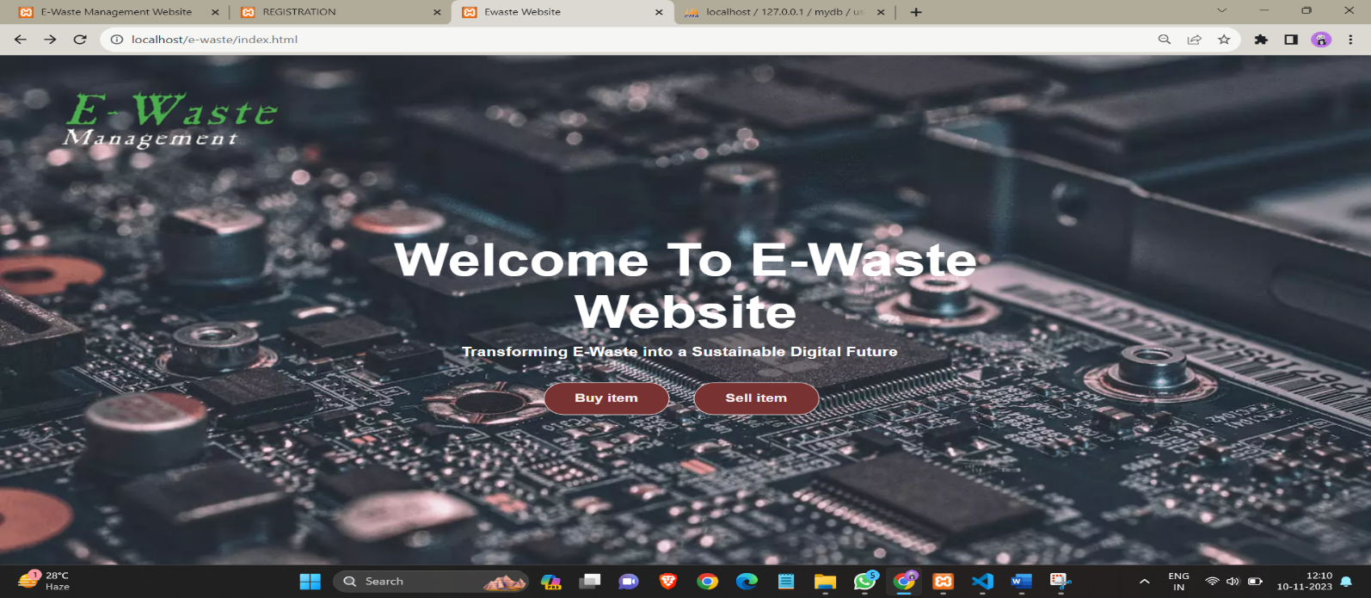

**6.6 Sell Item page:**

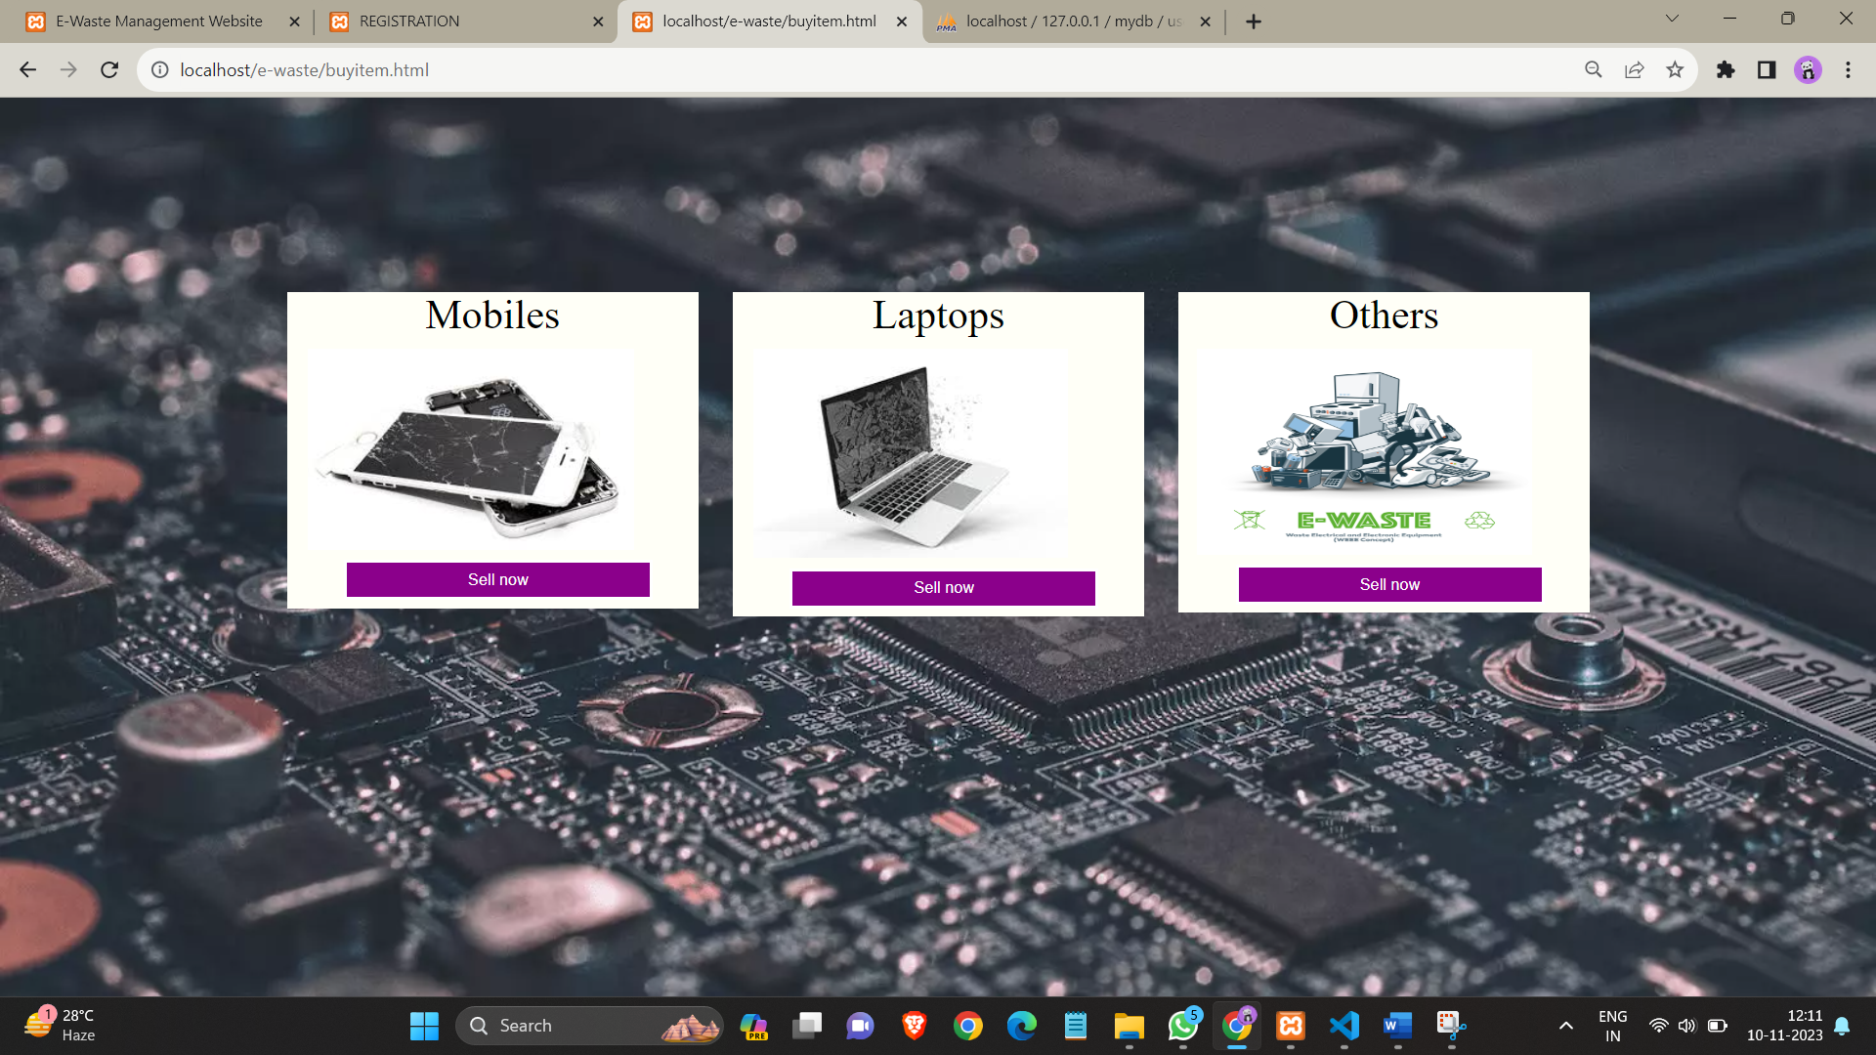

**6.7 Item selection page:**

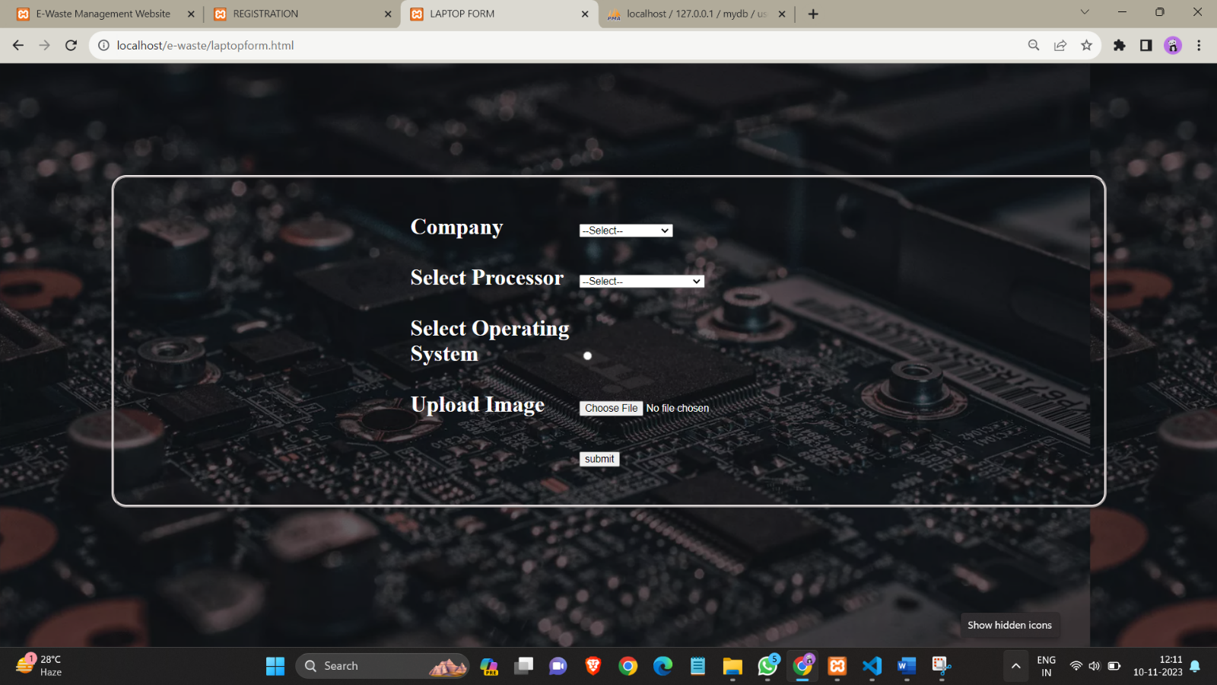

**6.9 Buy Item page:**

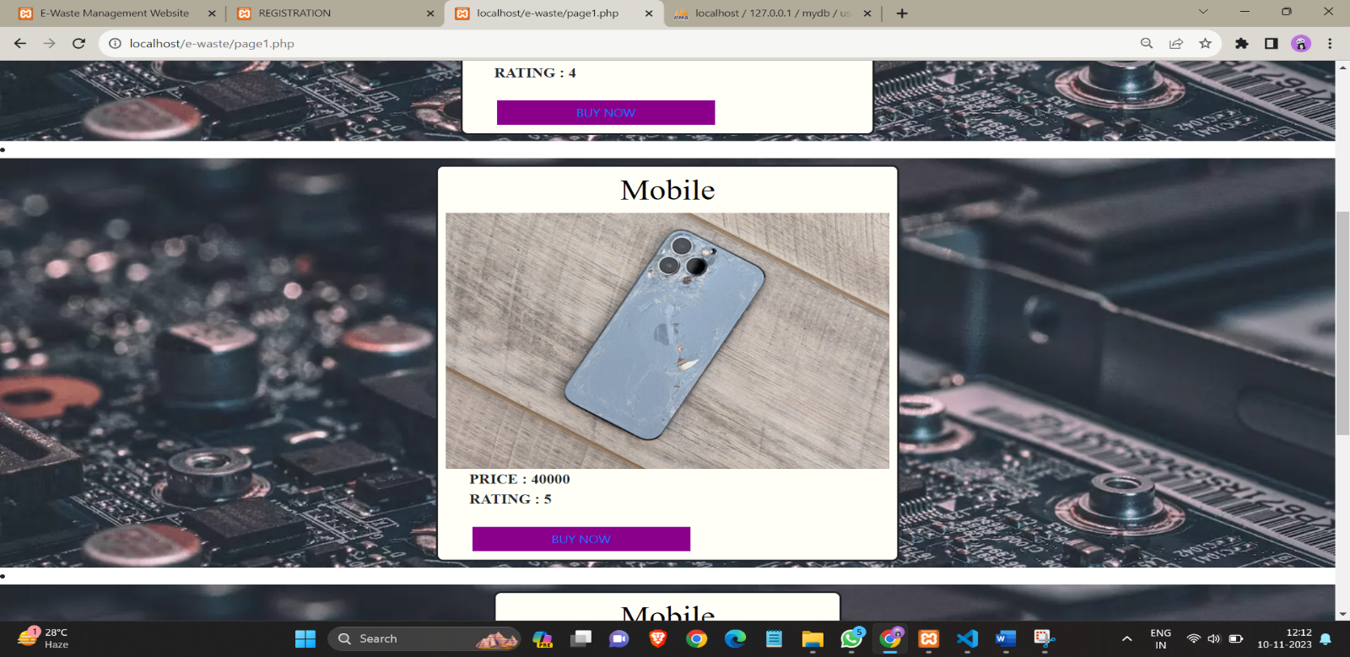

**6.10 Payment page:**

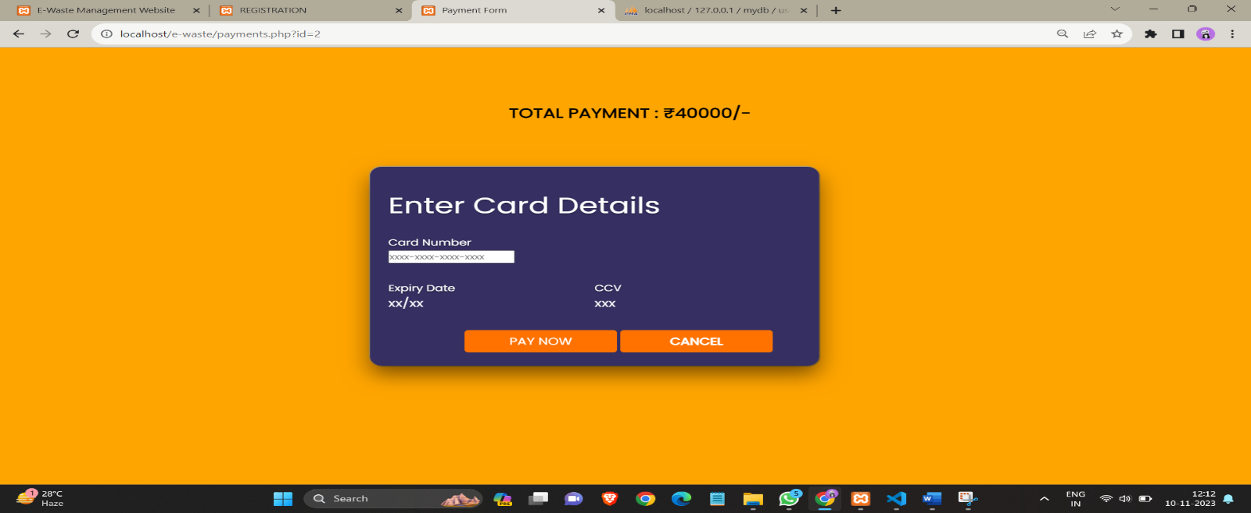

**6.11 Payment Acknowledgment page:**

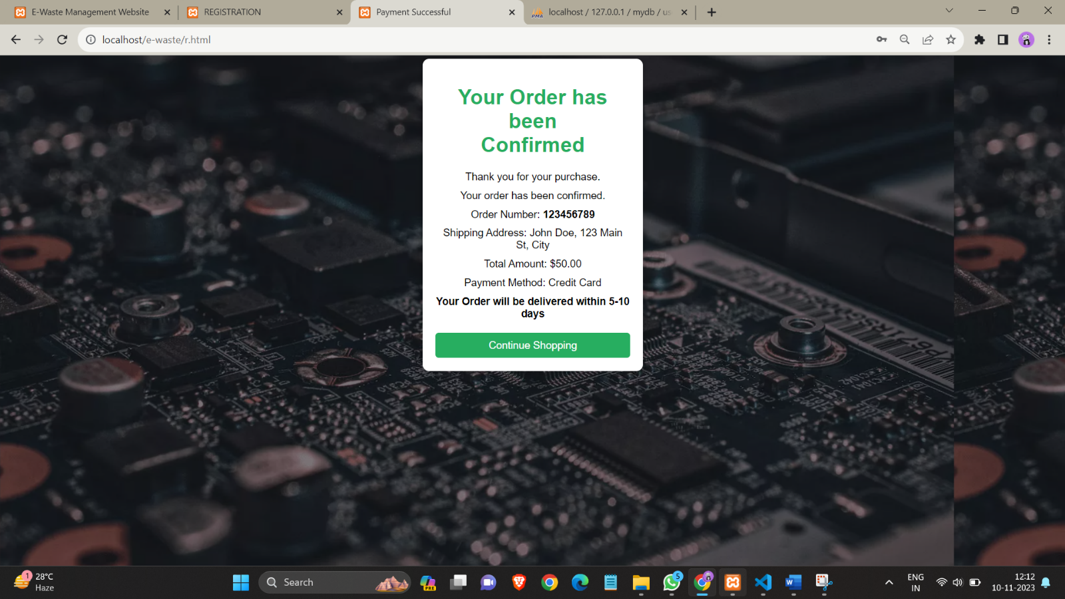

**6.12 About us page:**

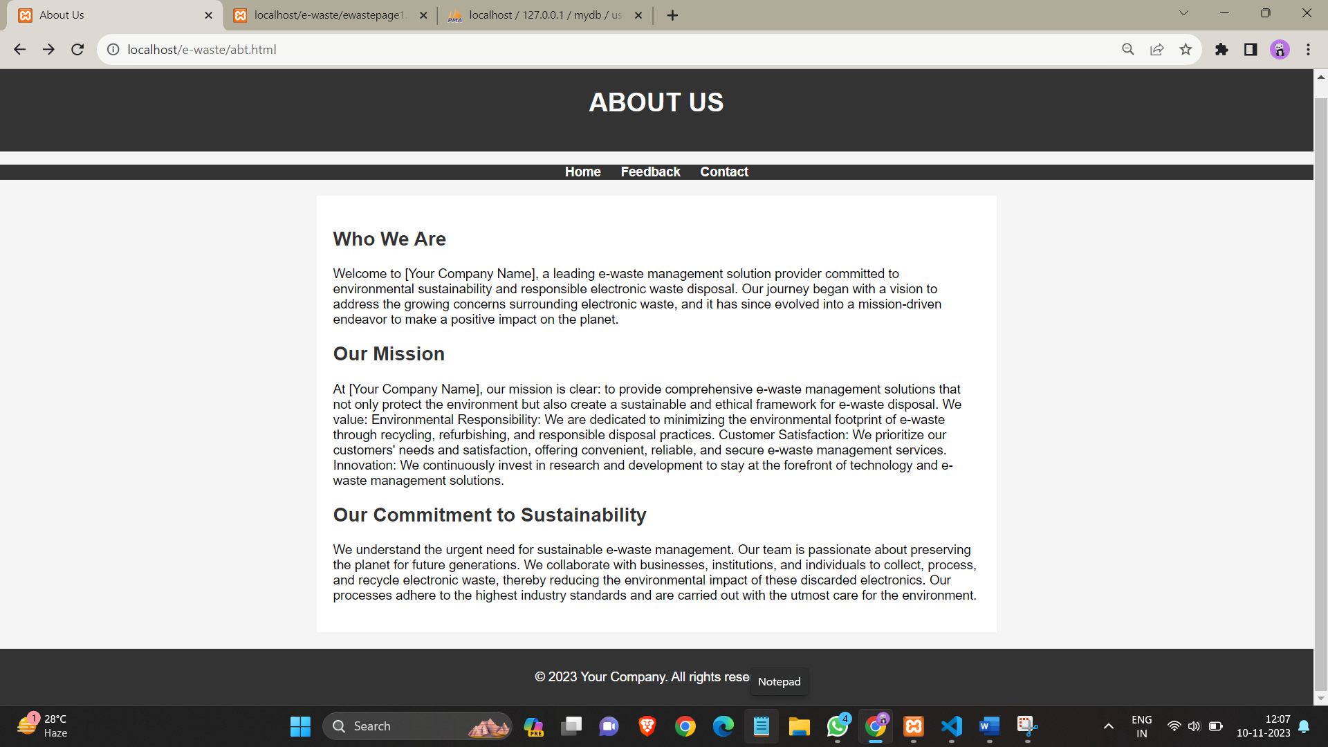

**6.13 Contact page:**

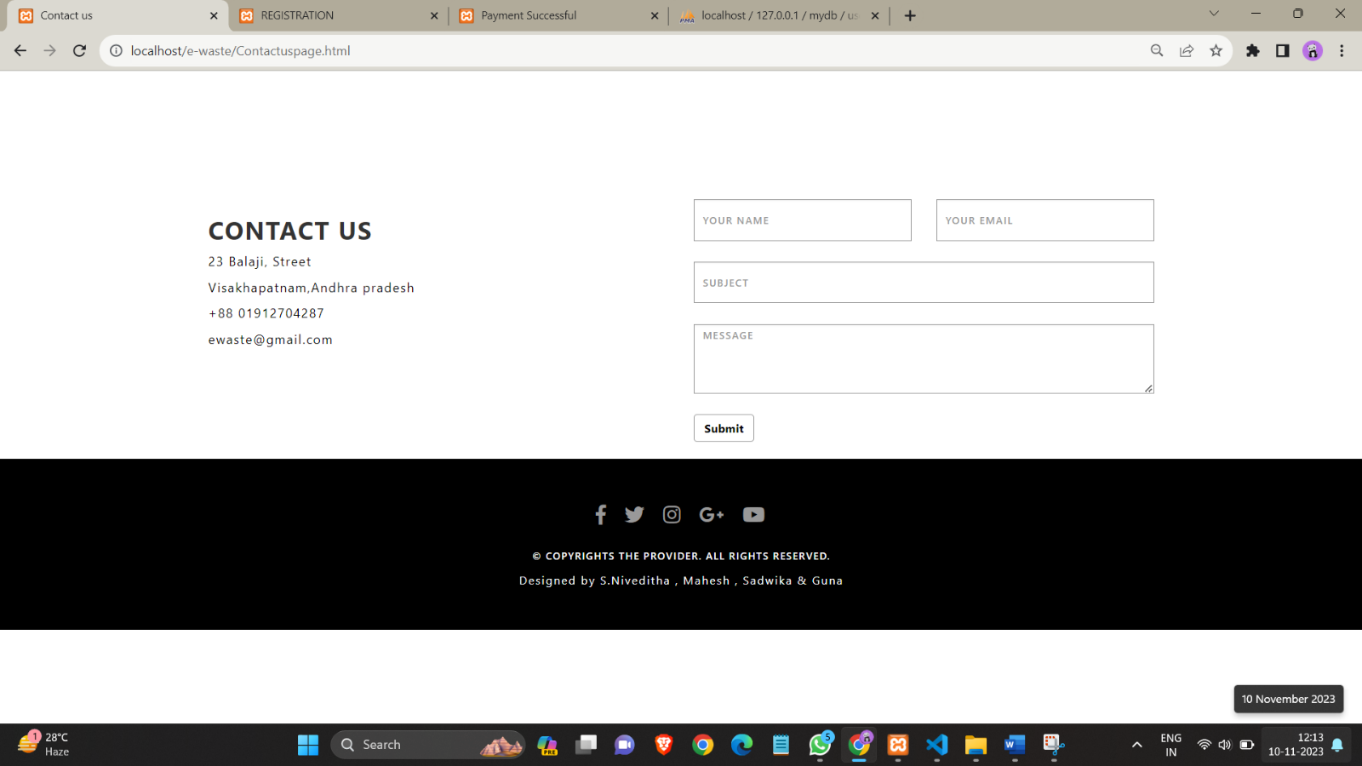

**6.14 Feedback form:**

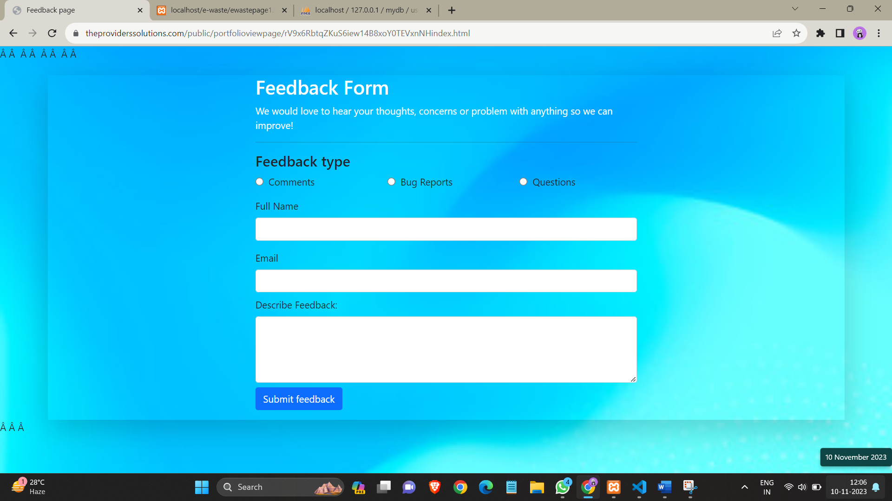

**CONCLUSION:**

In conclusion, our e-waste website, centred around reusable gadgets, marks a pioneering step in sustainable technology consumption. By promoting the use of durable and repairable electronics, we aim to curb the environmental impact of electronic waste. Through user engagement, informative content, and accessible resources, our platform encourages a shift towards responsible consumer choices. As we strive to build a community committed to minimizing e-waste, this project stands as a testament to the potential of technology to drive positive ecological change.